API List for the Project

1. Login

URL: <http://saidentalonline.com/API/loginAPI.php>

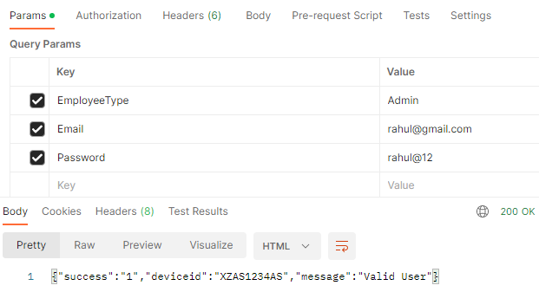

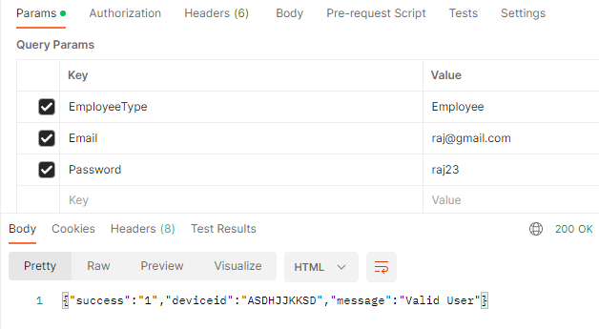

1. List of Teams for Each Employee/Admin

URL: <http://saidentalonline.com/API/TeamRetrieveAPI.php>

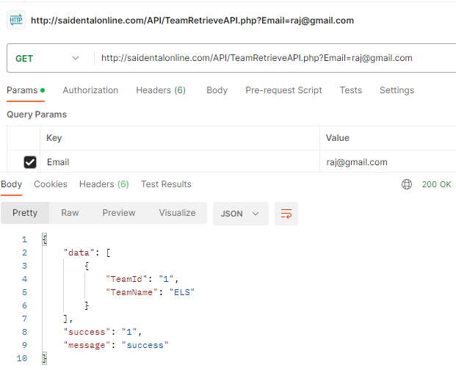

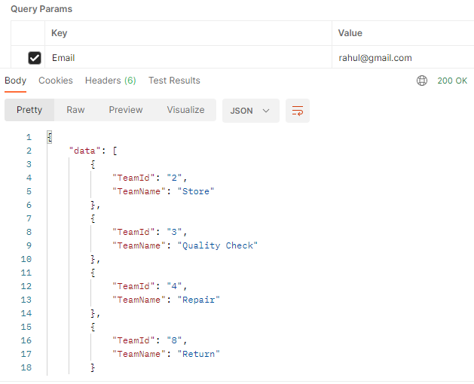

1. LotAddAPI

URL: <http://saidentalonline.com/API/LotAddAPI.php>

**Key Value List**

ProductType = Laptop

OrderDate = 2023-05-22

DeliveryDate = 2023-05-22

SupplierName = Adarsh Singh

LotName = Maha Deal

NumberOfUnits = 200

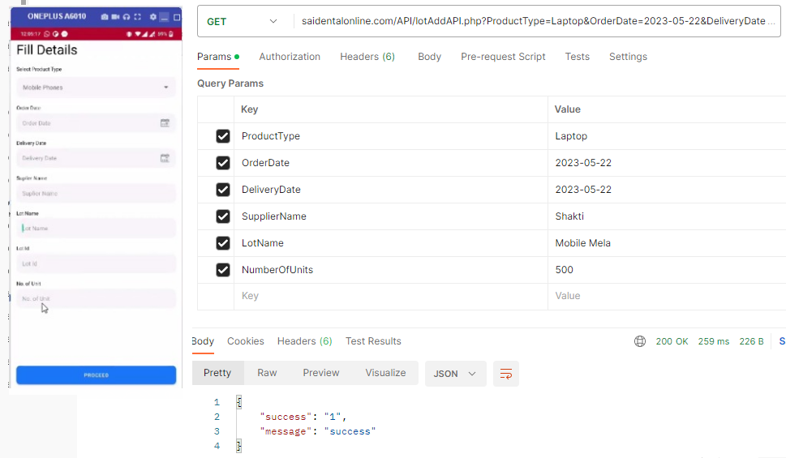

1. UpdateUserProfileAPI

URL: <http://saidentalonline.com/API/UpdateUserProfileAPI.php>

**Key Value List**

Email = rahul@gmail.com

Name = Rahul

Mobile = 9898765432

City = Patna

State = Bihar

Address = Shantikunj

DeviceId = AEDF12345A

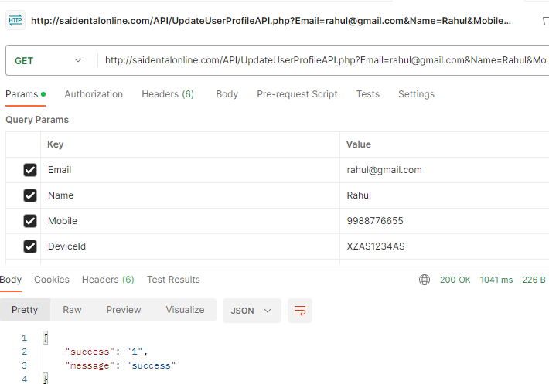

1. MobileEntryAPI (Without Images)

URL: <http://saidentalonline.com/API/MobileEntryAPI.php>

**Key Value List**

LotName : Mobile

Barcode : 1010001010100101

WSN : ASEDFFFFFF

Brand : Oneplus

Model : MO01

SwitchingOn : Yes

RAM : 8GB

ROM : 128GB

DisplayCondition : Good

BodyCondition : Very Good

IMEI : ASED23423213

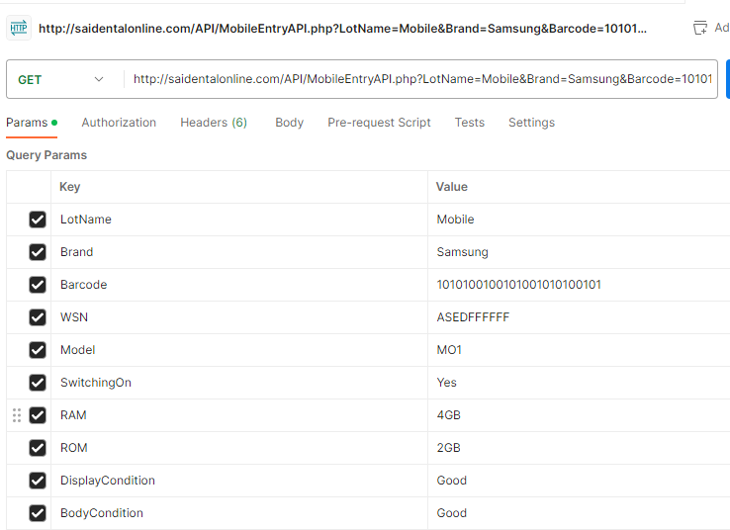

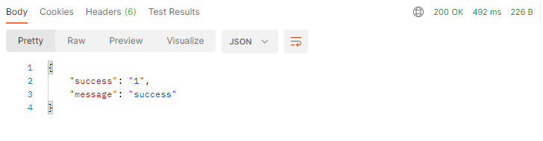

1. MobileEntryAPI (With Images)

URL: <http://saidentalonline.com/NewProject/MobileEntryAPI3.php>

POST

Key Value

===================

LotName: Mobile

Barcode: 1010001010100101

WSN: ASEDFFFFFF

Brand: Oneplus

Model: MO01

SwitchingOn: Yes

RAM: 8GB

ROM: 128GB

DisplayCondition: Good

BodyCondition: Very Good

IMEI: ASED23423213

Pic1Front: attach any image of small size(less than 7MB)

Pic2Back: attach any image of small size(less than 7MB)

Pic3Display: attach any image of small size(less than 7MB)

Color: Red

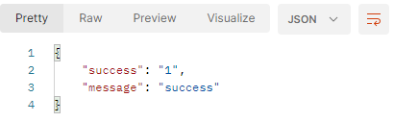

1. LaptopEntryAPI (With Images)

URL: <http://saidentalonline.com/NewProject/LaptopEntryAPI.php>

POST

Key Value

===================

LotName: Laptop

Barcode: 1010001010100101

WSN: ASEDFFFFFF

Brand: Oneplus

Model: MO01

SwitchingOn: Yes

RAM: 8GB

ROM: 128GB

HDD: 1TB

DisplaySize: 14inch

DisplayCondition: Good

BodyCondition: Very Good

HDD: 1TB

Pic1: attach any image of small size(less than 7MB)

Pic2: attach any image of small size(less than 7MB)

Pic3: attach any image of small size(less than 7MB)



1. AccessoriesEntryAPI (With Images)

URL: <http://saidentalonline.com/NewProject/AccessoriesEntryAPI.php>

POST

Key Value

===================

LotName: Accessories

Barcode: 100010101

WSN: JKHSEDFFFFFF

Brand: OPPO

Model: AO01

SwitchingOn: Yes

DisplaySize: 14inch

DisplayCondition: Good

BodyCondition: Very Good

Pic1: attach any image of small size(less than 7MB)

Pic2: attach any image of small size(less than 7MB)

Pic3: attach any image of small size(less than 7MB)

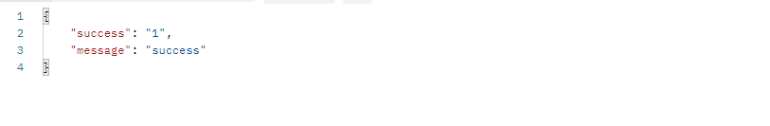

1. SparePartsEntryAPI (With Images)

URL: <http://saidentalonline.com/NewProject/SparePartsEntryAPI.php>

POST

Key Value

===================

LotName: SpareParts

Barcode: 000100101

Model: SO01

PartName: Charger

Color: Blue

Quantity: 12

Pic1: attach any image of small size(less than 7MB)

Pic2: attach any image of small size(less than 7MB)

Pic3: attach any image of small size(less than 7MB)



1. API to Get List of Trays

URL: <http://saidentalonline.com/API/ListOfTrayAPI.php>

No KEY/ parameters required

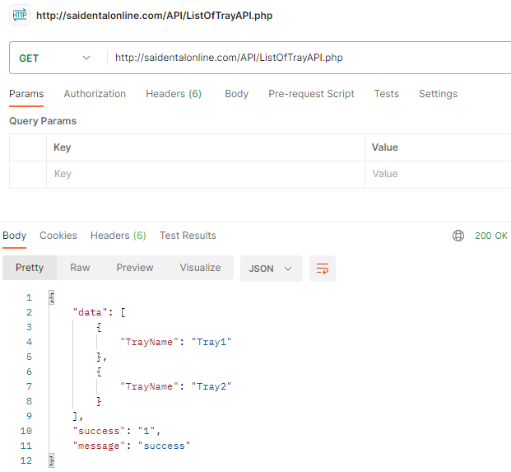

1. API to Retrieve Tray Detail

URL: <http://saidentalonline.com/API/TrayDetailRetrievalAPI.php>

Key Value

===================

TrayName: Tray1

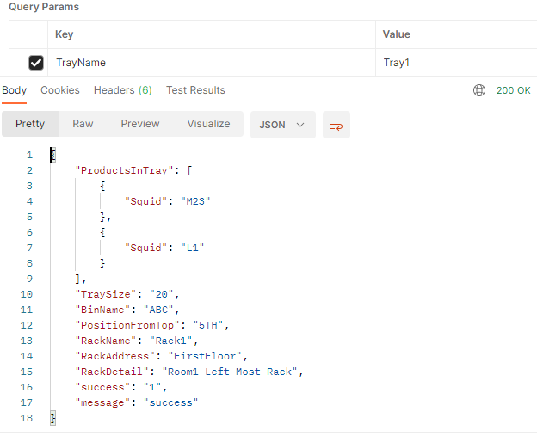

1. API To get Product SquId from Barcode at the time of ProductEntry in Tray

URL: <http://saidentalonline.com/API/SquidFromBarcodeAPI.php>

Note: Here ProductType is mandatory Key

Key Value

ProductyType laptop

Barcode 1001101

Key Value

ProductyType mobile

Barcode 10011011

Key Value

ProductyType accessories

Barcode 1001100

Key Value

ProductyType spareparts

Barcode 100110111

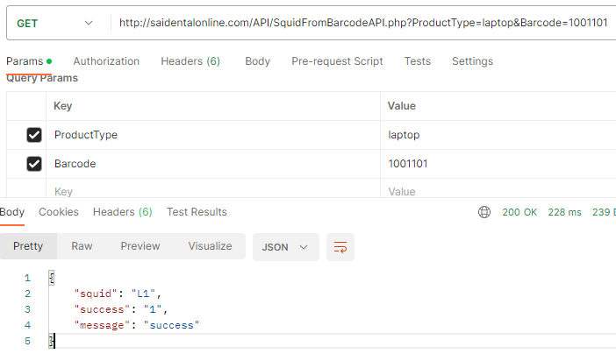

1. API to Get List of BIN with Bin and Rack Info

URL: http://saidentalonline.com/API/ListOfBinAPI.php

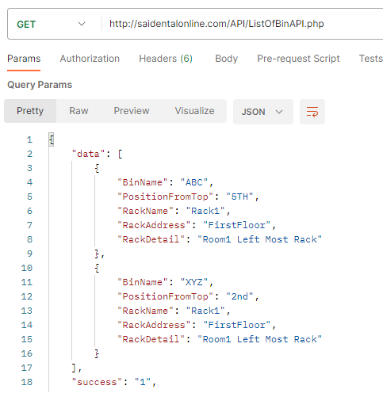

1. API to Add Product in Tray

URL: <http://saidentalonline.com/API/ProductAddToTrayAPI.php>

Key Value

TrayName Tray1

SquId L1

BinName ABC

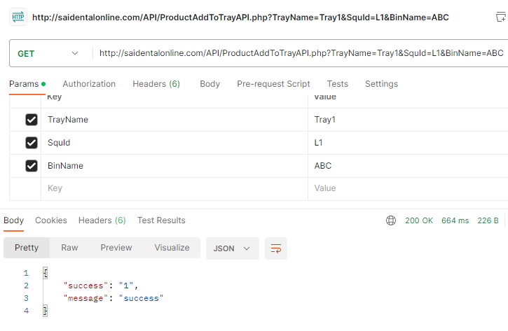

1. API To get Product Location From Product SquId

URL: <http://saidentalonline.com/API/ProductLocationFromSquidAPI.php>

Key Value

Squid L1

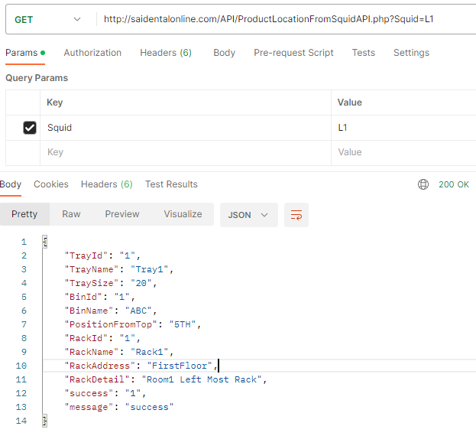

1. List of Admin in Team Quality Check

URL: <http://saidentalonline.com/API/QualityCheckAdminListAPI.php>

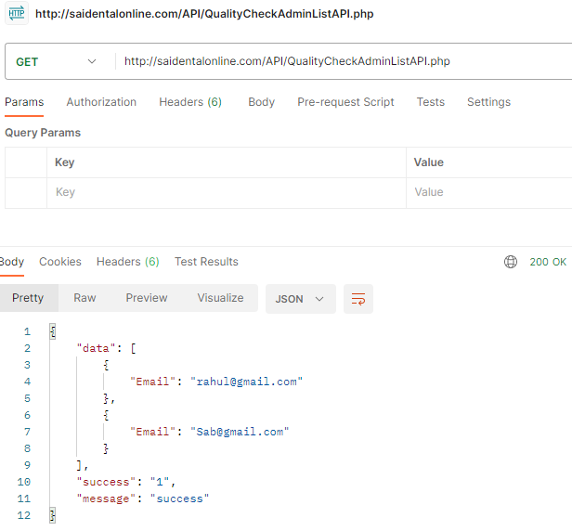

1. List of Employee in Team Quality Check

URL: <http://saidentalonline.com/API/QualityCheckEmployeeListAPI.php>

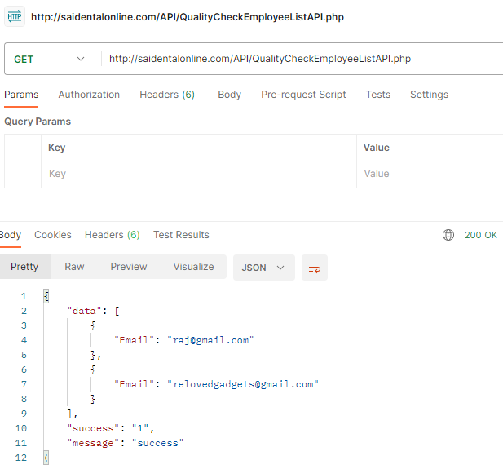

1. Allot Product to Employee for Quality Check

URL: [http://saidentalonline.com/API/](http://saidentalonline.com/API/QualityCheckEmployeeListAPI.php) AllotProductQualityCheck.php

Note: To use this API first we can see list of AdminEmail and EmployeeEmail from the above two APIs

Key Value

AdminEmail [rahul@gmail.com](mailto:rahul@gmail.com)

EmployeeEmail [raj@gmail.com](mailto:raj@gmail.com)

ProductSquid M1

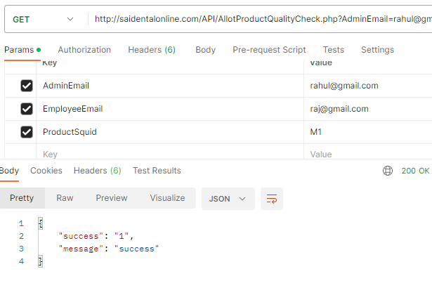

05-Jun-23

1. API to get list of Products allotted to an Employee

URL: [http://saidentalonline.com/API/](http://saidentalonline.com/API/QualityCheckEmployeeListAPI.php) ListOfProductsToEmployeeAPI.php

Note: The email of the employee can be obtained from API 17, List of employee under team Quality Check

Key Value

Email [raj@gmail.com](mailto:raj@gmail.com)

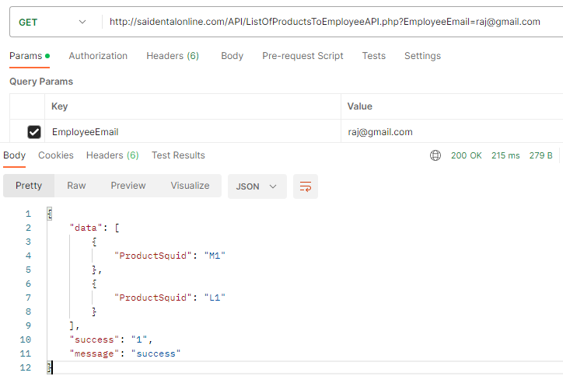

20 API to get Product History i.e. Date of Product Entry, Lot Entry Date and Allotment for Quality Check

URL: <http://saidentalonline.com/API/ProductMovementHistoryAPI.php>

Key Value

Squid M23

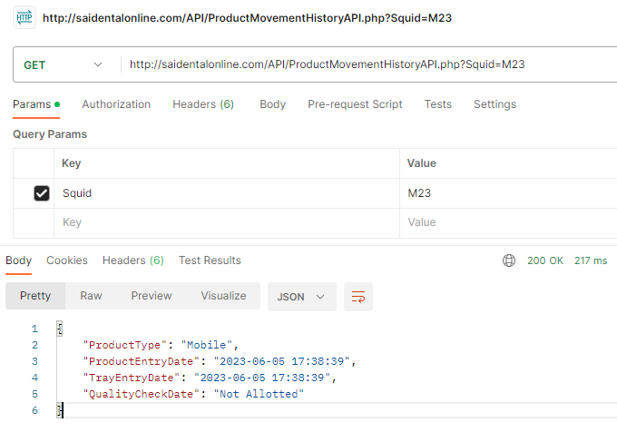

21 API to show Functional Check status for a Product by an Employee

URL: <http://saidentalonline.com/API/ShowFunctionalCheckStatusAPI.php>

GET API

Key Value

Squid M23

Email raj@gmail.com

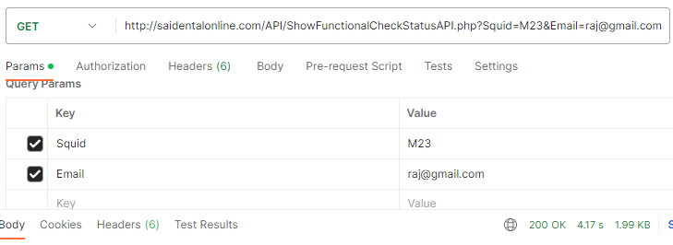

{

    "SrNo1": "1",

    "QCPoint1": "Network",

    "Status1": "Checked",

    "SrNo2": "2",

    "QCPoint2": "Mic",

    "Status2": "Checked",

    "SrNo3": "3",

    "QCPoint3": "Speaker",

    "Status3": "NotChecked",

    "SrNo4": "4",

    "QCPoint4": "Ringer",

    "Status4": "NotChecked",

    "SrNo5": "5",

    "QCPoint5": "Rotation",

    "Status5": "NotChecked",

    "SrNo6": "6",

    "QCPoint6": "Back Camera",

    "Status6": "NotChecked",

    "SrNo7": "7",

    "QCPoint7": "Front Camera",

    "Status7": "NotChecked",

    "SrNo8": "8",

    "QCPoint8": "Video",

    "Status8": "NotChecked",

    "SrNo9": "9",

    "QCPoint9": "Flash",

    "Status9": "NotChecked",

    "SrNo10": "10",

    "QCPoint10": "Auto focus",

    "Status10": "NotChecked",

    "SrNo11": "11",

    "QCPoint11": "Wifi",

    "Status11": "NotChecked",

    "SrNo12": "12",

    "QCPoint12": "Bluetooth",

    "Status12": "NotChecked",

    "SrNo13": "13",

    "QCPoint13": "Volume Buttons",

    "Status13": "NotChecked",

    "SrNo14": "14",

    "QCPoint14": "Power Button",

    "Status14": "NotChecked",

    "SrNo15": "15",

    "QCPoint15": "All Buttons",

    "Status15": "NotChecked",

    "SrNo16": "16",

    "QCPoint16": "Earphones",

    "Status16": "NotChecked",

    "SrNo17": "17",

    "QCPoint17": "Charging",

    "Status17": "NotChecked",

    "SrNo18": "18",

    "QCPoint18": "Display",

    "Status18": "NotChecked",

    "SrNo19": "19",

    "QCPoint19": "Touch",

    "Status19": "NotChecked",

    "SrNo20": "20",

    "QCPoint20": "Reflector",

    "Status20": "NotChecked",

    "SrNo21": "21",

    "QCPoint21": "Touch Buttons",

    "Status21": "NotChecked",

    "SrNo22": "22",

    "QCPoint22": "Body",

    "Status22": "NotChecked",

    "SrNo23": "23",

    "QCPoint23": "Back Panel",

    "Status23": "NotChecked",

    "SrNo24": "24",

    "QCPoint24": "Chrome",

    "Status24": "NotChecked",

    "SrNo25": "25",

    "QCPoint25": "Camera Glass",

    "Status25": "NotChecked",

    "SrNo26": "26",

    "QCPoint26": "Fingerprint",

    "Status26": "NotChecked",

    "SrNo27": "27",

    "QCPoint27": "Sound Quality",

    "Status27": "NotChecked",

    "SrNo28": "28",

    "QCPoint28": "Sound Volume",

    "Status28": "NotChecked",

    "SrNo29": "29",

    "QCPoint29": "Sensors",

    "Status29": "NotChecked",

    "SrNo30": "30",

    "QCPoint30": "Battery",

    "Status30": "NotChecked",

    "success": "1",

    "message": "success"

}

09-Jun-23

22 API to show All Racks, All Bin in Racks, All Tray with Products in Bin

URL: <http://saidentalonline.com/API/RackBinTrayProductAPI.php>

GET API

Key Value

N/A

{

    "Rack": [

        {

            "Rackid": "1",

            "RackName": "Rack1"

        },

        {

            "Bin": [

                {

                    "BinId": "1",

                    "BinName": "ABC"

                },

                {

                    "Tray": [

                        {

                            "TrayId": "1",

                            "Squid": "M23"

                        },

                        {

                            "TrayId": "1",

                            "Squid": "L1"

                        }

                    ]

                },

                {

                    "BinId": "2",

                    "BinName": "XYZ"

                },

                {

                    "Tray": [

                        {

                            "TrayId": "2",

                            "Squid": "M2"

                        }

                    ]

                }

            ]

        },

        {

            "Rackid": "2",

            "RackName": "Rack2"

        },

        {

            "Bin": [

                {

                    "BinId": "3",

                    "BinName": "Bin3"

                }

            ]

        }

    ],

    "success": "1",

    "message": "success"

}

**12-06-2023**

23 API to get lot details of all lots available

URL: <http://saidentalonline.com/API/LotDetailAPI.php>

GET API

Key Value

N/A

{

    "LotDetail": [

        {

            "LotName": "Mobile Mela",

            "ProductType": "Mobile",

            "OrderDate": "2023-05-22",

            "DeliverDate": "0000-00-00",

            "SupplierName": "Archana ",

            "SupplierInitial": "AR",

            "NumberOfUnits": "500",

            "UnitsFilled": "3"

        },

        {

            "LotName": "Delhi Deal",

            "ProductType": "Laptop",

            "OrderDate": "2023-05-22",

            "DeliverDate": "2023-05-22",

            "SupplierName": "Adarsh Singh",

            "SupplierInitial": "AS",

            "NumberOfUnits": "300",

            "UnitsFilled": "0"

        },

        {

            "LotName": "Maha Deal",

            "ProductType": "Laptop",

            "OrderDate": "2023-05-22",

            "DeliverDate": "2023-05-22",

            "SupplierName": "Adarsh Singh",

            "SupplierInitial": "AS",

            "NumberOfUnits": "200",

            "UnitsFilled": "0"

        },

        {

            "LotName": "Maha Deal Hello Singh",

            "ProductType": "Laptop",

            "OrderDate": "2023-05-22",

            "DeliverDate": "2023-05-22",

            "SupplierName": "Adarsh Singh",

            "SupplierInitial": "AS",

            "NumberOfUnits": "200",

            "UnitsFilled": "0"

        },

        {

            "LotName": "Mobile Mela",

            "ProductType": "Mobile",

            "OrderDate": "2023-05-22",

            "DeliverDate": "0000-00-00",

            "SupplierName": "Archana ",

            "SupplierInitial": "AR",

            "NumberOfUnits": "500",

            "UnitsFilled": "3"

        },

        {

            "LotName": "Mobile Mela",

            "ProductType": "Laptop",

            "OrderDate": "2023-05-22",

            "DeliverDate": "0000-00-00",

            "SupplierName": "Shakti",

            "SupplierInitial": "SK",

            "NumberOfUnits": "500",

            "UnitsFilled": "0"

        },

    ],

    "success": "1",

    "message": "success"

}

24 API to get lot details by LotName

URL: <http://saidentalonline.com/API/LotDetailByLotNameAPI.php>

GET API

Key Value

LotName Mobile Mela

{

    "LotDetail": [

        {

            "ProductType": "Mobile",

            "OrderDate": "2023-05-22",

            "DeliverDate": "0000-00-00",

            "SupplierName": "Archana ",

            "SupplierInitial": "AR",

            "NumberOfUnits": "500",

            "Unitsfilled": "3"

        }

    ],

    "success": "1",

    "message": "success"

}

14-Jun-23

1. Supplier Initial Added in Lot Detail API
2. API – 23
3. API – 24 Lot By Name
4. Color Option Added in Mobile Entry API

API – 6

1. Units filled in each lot added in API

API – 24

1. API to View All Suppliers Name and Initials

URL: <http://saidentalonline.com/API/ListOfSuppliersAPI.php>

GET API

KEY VALUE

N/A

{

    "data": [

        {

            "SupplierName": "Rajiv Ranjan",

            "SupplierInitial": "RR"

        },

        {

            "SupplierName": "Adarsh Singh",

            "SupplierInitial": "AS"

        },

        {

            "SupplierName": "Archana",

            "SupplierInitial": "AR"

        },

        {

            "SupplierName": "Shakti",

            "SupplierInitial": "SK"

        },

        {

            "SupplierName": "cc",

            "SupplierInitial": "cc"

        },

        {

            "SupplierName": "sab",

            "SupplierInitial": "ss"

        }

    ],

    "success": "1",

    "message": "success"

}

15-06-2023

1. API to update QCPoints of FunctionalCheck By Employee for a particular Product

URL: <http://saidentalonline.com/API/UpdateFunctionalCheckAPI.php>

GET API

Key Value

[Email raj@gmail.com](mailto:Email%09%09%09raj@gmail.com)

Squid M23

QCPoints Network

Status N

Note: Status = N for Not Checked

Status = Y for Checked

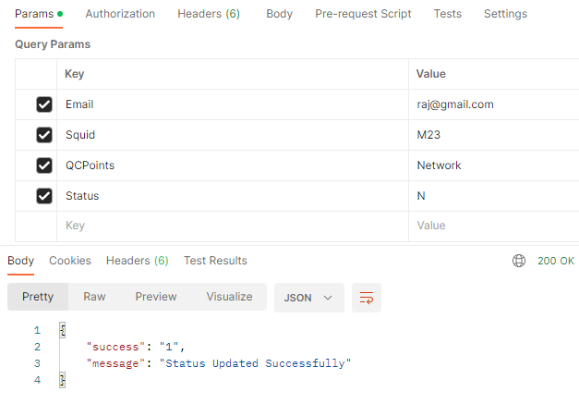

1. API to Get List of Products in A Lot by LotName

URL: <http://saidentalonline.com/API/ListOfProductInLotAPI.php>

GET API

Key Value

LotName Delhi Deal

